Admin Notes

Contents

Purpose 2

Sections 3

iBS/Iptor 3

Office 365 3

NovaTime 3

SendGrid 3

Accounting 3

Art Department 3

Misc 3

Wix 4

● To call Wix Support directly: 4

iSeries ODBC 5

Dashboard 7

Linked Servers 8

Source control 9

Terminal Server 10

VMware 11

# Purpose

I will list miscellaneous items in this document that I want to record for different reasons.

# Sections

The following sections are notes that I wanted to record.

## iBS/Iptor

iBS I guess has changed its name to Iptor and has a new portual.

gmailid/iPtorDu8@0U4

The system is scheduled to go down daily from midnight to 6:30 am, to perform backups and run IBS processes.

## Office 365

We have a 365 account for installing Office. At times I have used it to install software for people.

<https://login.microsoftonline.com/>

[home@vincentprinting.onmicrosoft.com](mailto:home@vincentprinting.onmicrosoft.com)

vpiH$meUser

email/msDu8&0U4

Not sure but I think this is the admin password Admin365

## NovaTime

64911/Vincent01

For software support talk to Kevin 513-733-5300 or 1-800-454-8463 [support@cincinnatitime.com](mailto:support@cincinnatitime.com) The db for Novatime login nti_cs csadmin

## SendGrid

We are currently using SendGrid to send emails for our Whitelabel companies. At the time of this writing there is only Miller but I am sure we will add more.

vpiuser/vpi160108

## Accounting

Sometimes accounting has requests for help on various tasks. They are recorded here.

Create an ODBC connection for them. They have an Access database with reports in it that requires an odbc connection. The following is an example of such a connection.

## Art Department

The art department uses apple products so it can be a complete different set of issues for them.

* IP used by another user, some of their computers use static ips for Caldera.
  + Their personal one should still get an assigned one from the DHCP.
* Caldera has several reserved ips for that software.

## Misc

Various id

vinwork/v1nW@rk for network processes for Matt

Vinyl Print / vinylPr1nt generic id.

[scochran@scsga.com](mailto:scochran@scsga.com) [sguhne@scsga.com](mailto:sguhne@scsga.com) sorteluser

vpi/vp1u2@r for FileZilla on Web1

steve@esko win 10 pwd

MSDN email/msDu8&0U4

WIX email/v1nm@il

## Wix

User id [Michael@VincentPrinting.com](mailto:Michael@VincentPrinting.com) Printing

### To call Wix Support directly:

* + From the U.S. dial toll free 1-800-6000-WIX (949)
  + From the UK dial toll free +44-808-164-1677
  + From all other countries dial +1-415-639-9034

## 

## 

## iSeries ODBC

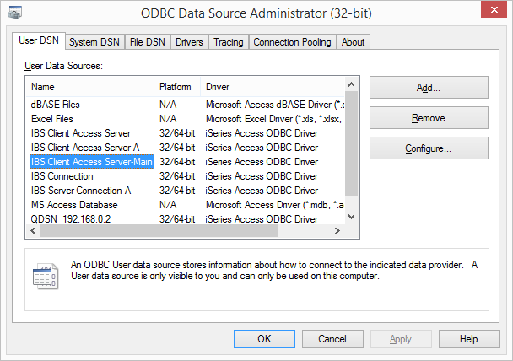

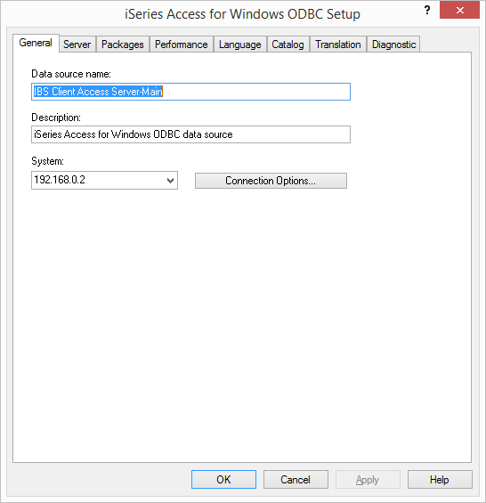

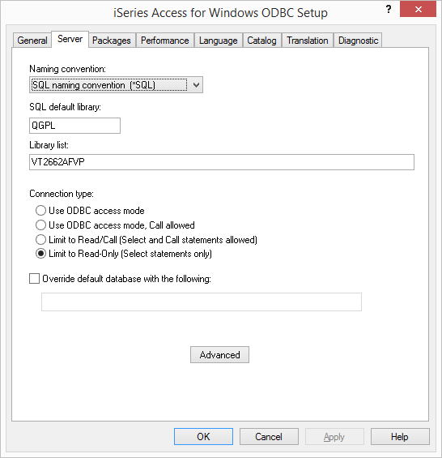

## Dashboard

The dashboard shows MFG totals for the given period. I create a connection that information follows.

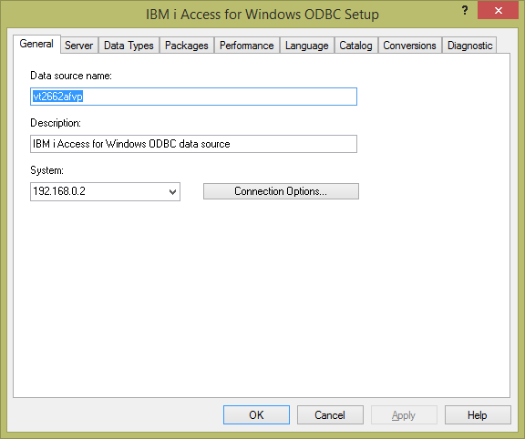

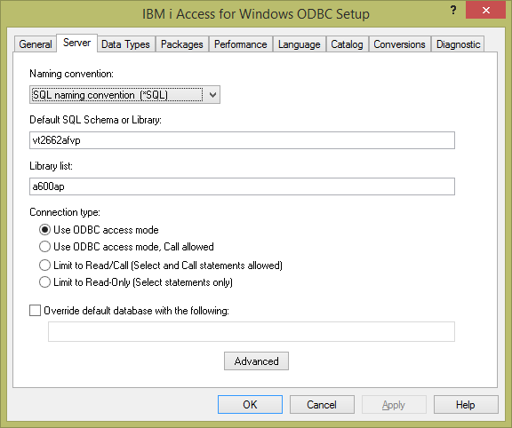

## Linked Servers

In order to set up a linked server you will need to set the following options on the provider.

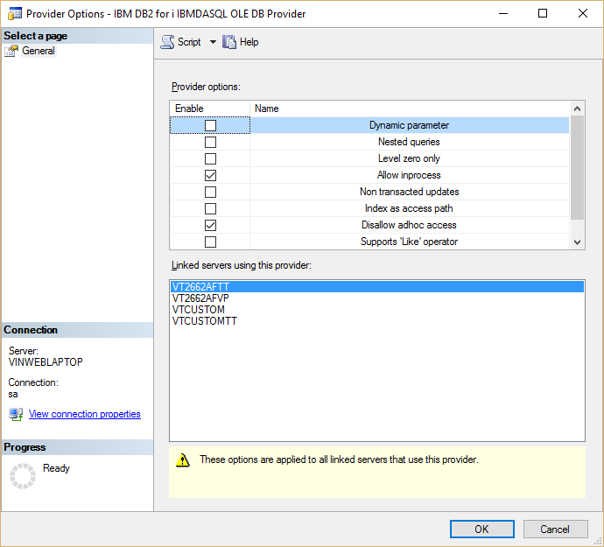

## Source control

This section documents the information for the source control. We have installed the Bonodo Git Server on Web2012 (23).

<http://web2012-rep/Home/LogOn>

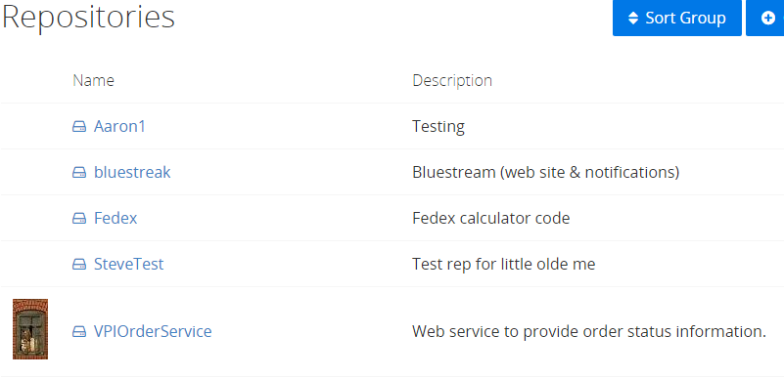

I had to modify the local .git/config file to point it at our server for this project.

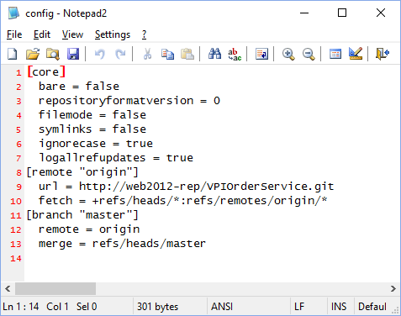

## Terminal Server

So, we have a terminal server for the Art departments use. I am recording issues that I found over time here.

Over time some users do not sign off. An issue popped up about users getting disconnected from the server.

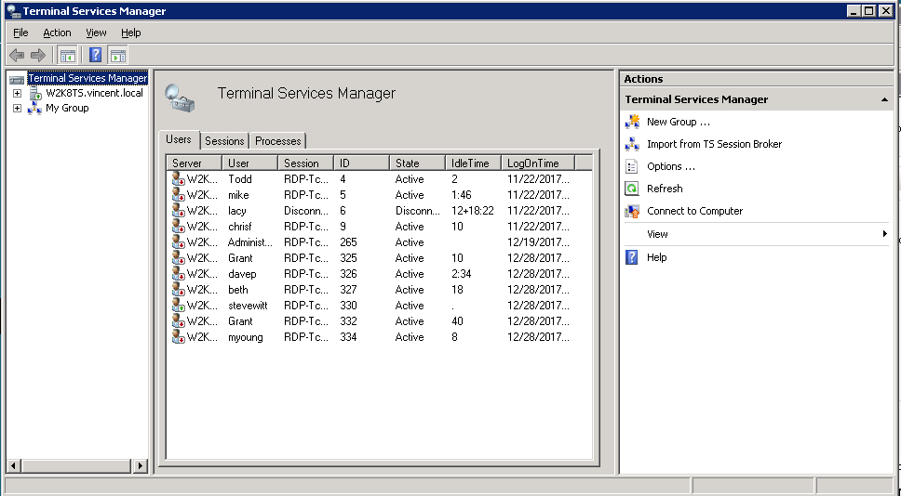

I believe that it is either that because the server is never restarted that this might be the cause. I plan to add this server to the reset tasks in Vmware.

## VMware

I am recording issues or topics for VMware here.

Scheduled Tasks

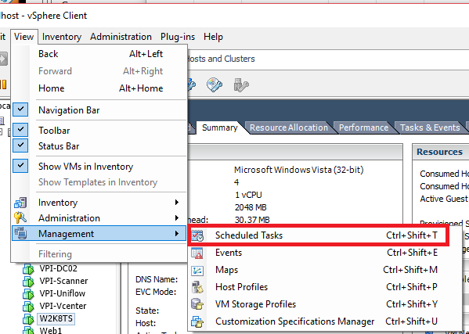

I have set up several of the servers to reset at 1 a.m. on Sunday.

